**Mrs C.A. Watkins (Rene)**

*Achievements*

*MacRobertson Shield Team*

*1930 in Australia*

*1940 Although the triangular series was to be held in New Zealand as part of this country’s centennial celebrations it was cancelled. Team members were individually awarded the Centennial Gold Badge.*

*1956 – in England*

*NZ Representative Match*

*1928 – in New Zealand*

*NZ Open Champion 1938, 1940, 1941, 1952*

*Runner-up 1933, 1946, 1949, 1954*

*NZ Open Doubles*

*1924 with H P Stratton*

*1926 with Mrs M Pitcaithley*

*1931 with Mrs F A Tiffen*

*1936 with A G F Ross*

*1940 with J Tannock*

*1946 with F C Bryan*

*1953 with Clem Watkins*

*1954 with Clem Watkins*

*1955 with Clem Watkins*

*1961 with Jack Tucker*

*New Zealand Women’s Champion*

*1924, 1926, 1931, 1941, 1944, 1947, 1955*

*North Island Open Champion 1923, 1926*

*North Island Women’s Champion 1923, 1935, 1936, 1955*

*North Island Open Doubles*

*1926 with H P Stratton*

*1932 with Mrs F A Tiffen*

*1936 with H P Stratton*

*1938 with H P Stratton*

*1955 with C A Watkins*

*South Island Women’s Champion 1954*

*South Island Open Doubles*

*1937 with H P Stratton*

*1954 with C A Watkins*

*NZ English Gold Medal 1932*

*NZ English Coronation Bronze Medal 1954*

Born: 1897 Died: 1967

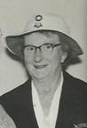

Mrs C.A. “Rene” Watkins, nee Serena Eliza Bishop, was born in 1897. She married Clem Watkins in 1915. In 1938, Rene, a member of the Hastings Croquet club, won the first of her of her four Open Championship titles. In later years Ashley Heenan described her as the best woman player New Zealand had produced. Playing with an upright side stance, similar to that of present day player, Stephen Forster of Australia, she was an extremely determined competitor and with husband Clem won the Doubles Championship three years in succession 1953, 54 and 55.

(*Extract from a history of the New Zealand Open Championships by John Prince)*

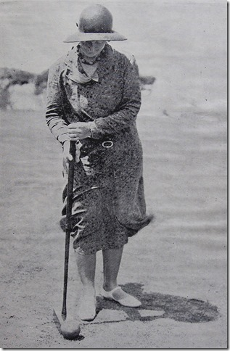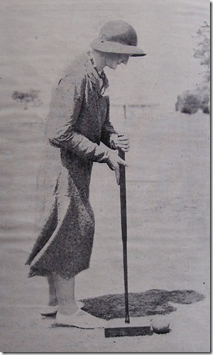

**Rene Watkins – “Croquet and how to play it” A.G.F. Ross**

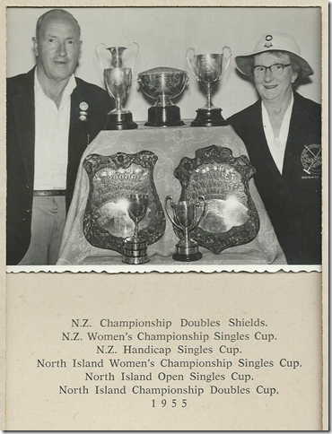Her career was extensive as the CNZ Honours Board indicates. She was a MacRobertson team member 1930 and 1956. Her last title was the NZ Open Doubles in 1961 with Jack Tucker – her tenth NZ Open Doubles title. She was 4 times NZ Open Champion. This suggests to me she was the greatest NZ women’s player, and comments made by Arthur Ross and Ashley Heenan to me confirm this. With husband Clem they won the NZ Doubles 3 times in a row. She was a great match player, never giving in no matter how bleak things got, the same sort of tenacity Susan Grigg (Wiggins) had. She was a very stylish player, and although I only saw her briefly in 1960 it still all looked very smooth, Ashley commented, “You are getting a little glimpse of one of our greatest and very stylish players, my boy”. *(John Prince)*

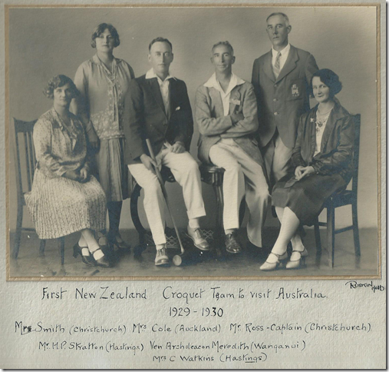

Achievements