Mrs B.A. (Jean) Jarden

Achievements:
MacRobertson Shield Team
1963 in New Zealand
1969 in Australia
NZ Representative matches
1969 in Australia (x3)
NZ Open Champion 1966
NZ Open Championship Runner-up 1961, 1962, 1965, 1967
Heenan Plate, 1969 1970, 1973
NZ Women’s Champion 1958, 1959, 1961, 1963, 1964, 1966, 1970, 1971, 1972
NZ Championship Doubles
1956 with Miss M Claughton
1965, 1966 with J G Prince
1967-69, 1971 with G.D. Rowling
NZ Handicap Singles Hurlingham Cup 1962
North Island Open Champion 1961, 1966
North Island Women’s Champion 1961, 1965, 1967
North Island Open Doubles
1961 with Mrs G Collins
1965 with Mrs T Harwood
1971 with J G Prince
South Island Women’s Champion 1962, 1964, 1968
President’s Invitation Best 8 1966
NZ English Coronation Silver Medal 1959, 1967
NZ Gold Mallet 1970
NZ Silver Mallet 1979
NZ Veterans Ladies’ Champion
1981
NZ Veterans Doubles with C J Read 1981, 1982
Overseas Events
The Croquet Association (CA) President’s Cup 1970 (fifth)
Chairman’s Salver 1972 (winner)
The CA Women’s Champion 1970, 1972
The CA Ladies Field Cup (Invitation) winner 1970, 1972
The CA Silver Medal 1970
The CA Mixed Doubles Championship 1972 with B G Neal (UK)
Irish Open Champion 1970

Born: 1907 Died 1983
Inducted into the World Croquet Federation Hall of Fame in 2015
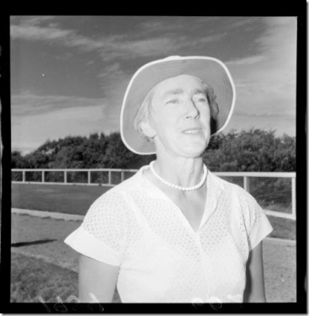

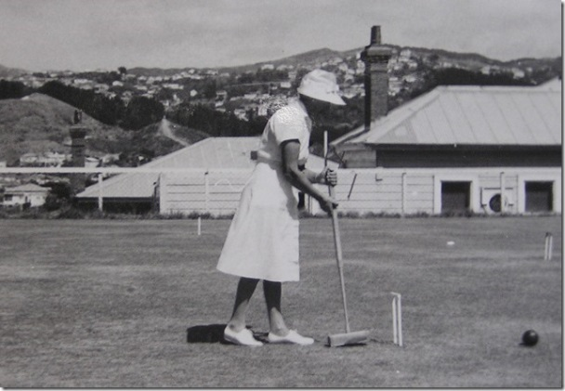
Jean Jarden at Wellington Municipal Croquet Club Wellington early 1960s

Mrs Jean Jarden, nee Jean Johnston, was born in 1907. She married Benjamin (“Ben”) Jarden in 1932.
In the late 1970s Jean Jarden was generally regarded as the best women’s croquet player in the world. She was also regarded as one the three best Kiwis among the NZ Women and was very competitive in open events.
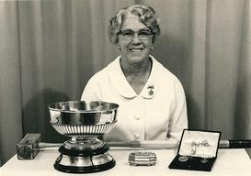
Mrs Jean Jarden with trophies won in the UK in 1970: the All England Women’s Championship; the Irish Open; the Gilbey Cup (a leading handicap event). Jean Jarden was the mother of the famous All Black Ron Jarden.

The following are memories of Jean from John Prince.

Jean played with a very upright side style holding the mallet with both hands at the top. She was a very reliable shot, hardly ever missing at 10-12 yards.
During her match in the 1963 MacRobertson against England at Hamilton, her opponent Pat Cotter unwisely dribbled at Jean’s tice, missed and finished on the boundary level with hoop two. Jean promptly hit the tice dead centre effectively rushing it to Cotter’s ball and established a break to 4 back.

When stalking a long shot, she would pick out a spot about 2 yards ahead of her ball and focus on that spot throughout the shot. When I first saw her playing in the early 60’s, like nearly every player she would take the longer defensive lift shots usually from “B” baulk at partner centre court. Around the 70’s players started to take on the short lift from time to time and Jean became very consistent, so much so that I’d often lay up quite wide apart when I played her.

Her break play was very tidy and once she established a break she rarely lost control of it. Like others, she did, however, find half rolls, rolls and pass rolls difficult playing with both hands at the top of the mallet, especially on slow courts. Her number one fan husband Ben watched every game she played, and would often comment if she failed to pick up a break with a big croquet stroke. Several people tried to get Ben, who never played, to sit the Referee’s exam as he’d become quite an authority on the game but he much preferred to follow every shot Jean played. Her All Black son Ron would often send her telegrams during a tournament which just said, Head down, follow through etc. Jean was being interviewed by the Press at Waimarie during a tournament and Ron had dropped by to see she how she was getting on. The reporter said, and of course you are the mother of the famous All Black wing three-quarter, whereupon Ron said, “No, I’m just the son of a famous N.Z. croquet player!”

