Tony Stephens
Achievements

MacRobertson Shield
1963 – in New Zealand
1996 – in England
Representative Matches
1990 – in New Zealand
1996 – in Wales
Trans-Tasman Open Croquet Test
1995 (Captain) – in Australia
NZ Open Champion
1960 Runner-up: 1971, 2004
Heenan Plate
1994
NZ Men’s Champion
1960, 2009
NZ Championship Doubles
1960 – with ADJ Heenan
1972 – with R J Clarke
NZ President’s Invitation event First Eight 1998 winner
NZ Handicap Singles Hurlingham Cup 1960, 1971
North Island Open Champion 1991
Sonoma Cutrer World Championship
Block winner 1997
Silver Medallist 1997
United States Open Champion 1994
United States Open Champion ship Doubles
1994 – with Dr W Berne (USA)

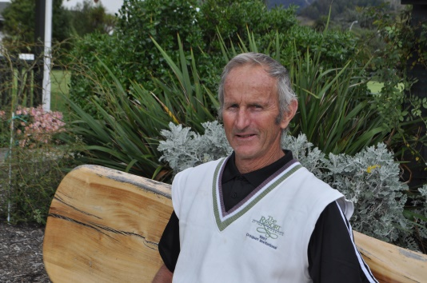
Born: 1944

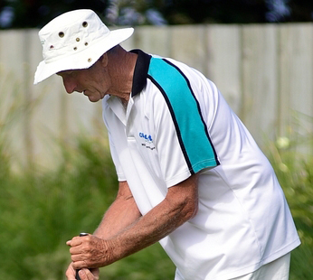

Anthony J Stephens hit the ground running when in 1960 as a teenager he captured the New Zealand Open Championship, The New Zealand Handicap Singles, The Men’s Open Championship and the New Zealand Championship doubles with his mentor Ashley (ADJ) Heenan. A true grand slam – all 4 titles at the same tournament - and at the age of 16. (Tony was the third player to have achieved this feat, Clem Watkins having done so in 1954 and Ashley Heenan in 1958.) Tony was a member of the 1963 and 1996 MacRobertson Shield Teams.
Tony Stephens is one of the most popular croquet players in the world. Each year, he travels the globe to play croquet, usually in company with wife Colleen and/or other family members, all of whom play the game well. Stephens is one of a handful of international stars who have played numerous American rules tournaments and have learned the America rules game well enough to consistently reach the final rounds. He has been very, very good at croquet for a long time, without taking himself too seriously. About half of what he says, by my estimate, is tongue-in-cheek.--Bob Alman

Tony became a dairy farmer in Dannevirke and played with his parents and sister at the Rangatira club. The playing family extends to Tony’s wife Colleen and daughters Sonya and Erica. In his youth Tony was also a pole vaulter, and a decathalete after which he was a billiards champion.

He has had a low profile over the years. However, in 1994 he won the Heenan Plate at the NZ National championships and followed this achievement by winning the USA Open champion ship and the Championship Doubles. In 1998 he won the NZ President’s Invitation Event First Eight. In 2009 Tony again won the New Zealand Men’s Championship – 50 years after his first success.

Tony has moved his primary focus to Golf Croquet although he still plays a great Association game. He now lives in Havelock North and is an orchardist.
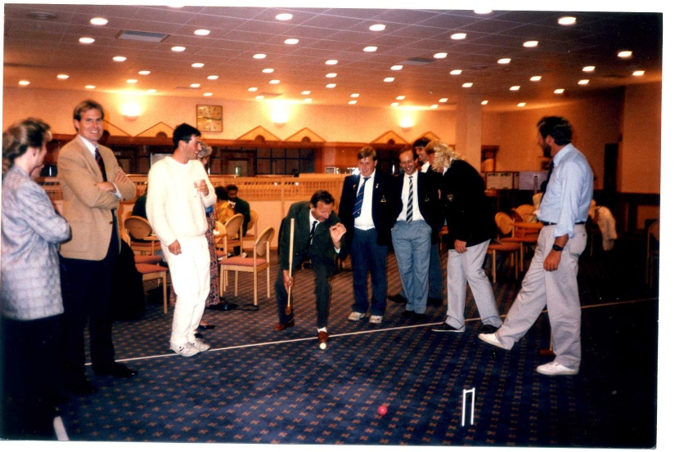

Indoor Croquet after the 1996 MacRobertson Shield dinner at Wimbledon – Tony uses his Billiards skills to “thread” the hoop

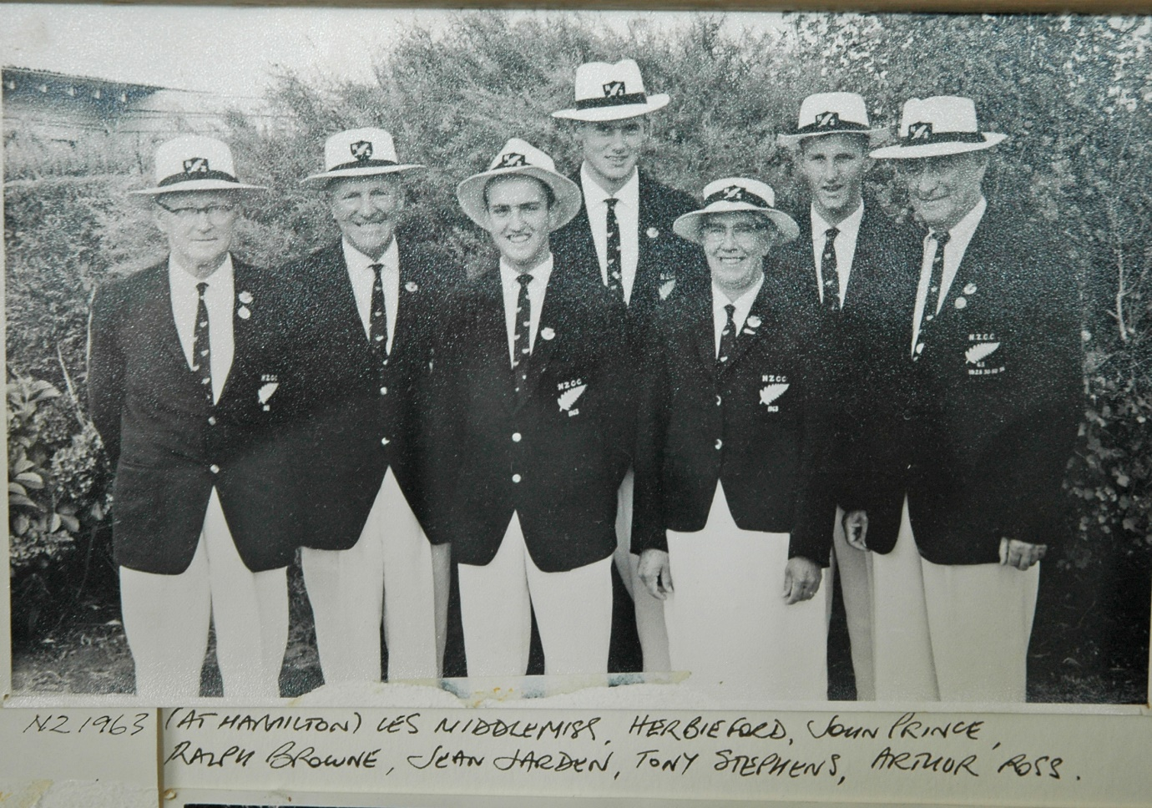
The New Zealand team for the 1963 test match against England played at Hamilton
Left to right: Les Middlemiss, Herbert Ford, John Prince, Ralph Browne, Jean Jarden, Tony Stephens, Arthur Ross

