John Prince MNZM
Born: 23rd July 1945

Achievements:
Life Member Croquet New Zealand 2000
Canterbury Croquet Association Life Member
MacRobertson Shield Team
Team Member 1963, 1974, 2000, 2003
Captain and Team Member
1969, 1979, 1982, 1986
Non-Playing Captain/Manager
1996
NZ Representative Matches
1963 in New Zealand
1969 in Australia (2)
1974 in Scotland
1982 in Australia (Captain)
1986 in England (Captain)
NZ Open Champion 1967, 1968, 1969, 1971, 1976, 1977, 1987, 2002
Runner up 1982, 1989
Heenan Plate 1972, 1995
NZ Men’s Champion 1963, 1964, 1967, 1968, 1969, 1970, 1971, 1972, 1999
Runner up 1975 to Alan Anderson
NZ Championship Doubles
1964 with Ashley Heenan
1967 - 68 with Jean Jarden
1970 with Keith Woollett
1975 with Richard Clarke
1977 -78 with Alan Anderson
1992 -93 with Greg Bryant
1999 with Graham Beale
2002 with Terry Walker.
NZ Best “8”or “10” Winner 1964, 1967, 1969, 1970, 1973, 1974, 1983, 1997
NZ Gold Mallet 1974
NZ Silver Medal 1990, 1995
NZ Handicap Singles 1964
North Island Open Singles 1971, 1987
South Island Open Singles 1989, 1993-94
Overseas Events
The Croquet Association Open Championship Doubles
1974 with Gordon Rowling
Sonoma Cutrer World Champs Silver Medallist (Block winner), 1987, 1993
Inducted into the World Croquet Federation Hall of Fame in 2007
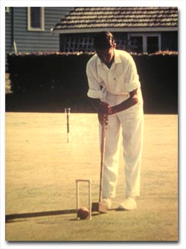
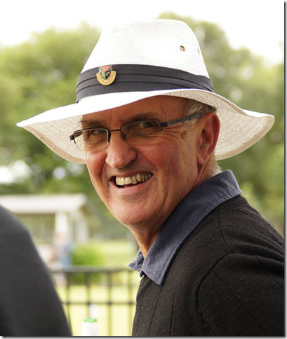
John Prince playing his way to the top trophy in the Men's final of the New Zealand Championships in 1963

John Graham Prince commenced playing Croquet at the NaeNae Croquet Club, Wellington, New Zealand, situated in the Lower Hutt Hospital grounds, in 1959 by sheer chance.
As a 14 year old schoolboy he had seen the game being played from the local swimming baths that overlooked the Lower Hutt Croquet Club in Riddiford Gardens and was intrigued enough to borrow "Croquet Today" by Maurice Reckitt from the local library. He visited the Naenae Club near his home and was fortunate to be invited to have a game by members Melba Miller and Muriel Palmer.
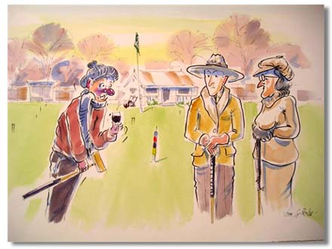
John Prince a noted watercolourist painted this fond memorial to these kind ladies who invited him to "have a go" at the Naenae club in his 16th year. If Melba Miller and Muriel Palmer, who both enjoyed a drink after a day’s play, had not encouraged the awkward youth, he likely would not have won the New Zealand Championships in his 17th year.
Shortly after Ashley Heenan was approached and agreed to coach John. His career literally took off, at aged 17 with practically no tournament experience he made a late debut into the New Zealand MacRobertson Shield Team, after winning his singles and doubles matches for a North Island team against the Australian visitors. He caused something of a sensation during the third Test Match England v New Zealand, when he defeated John Solomon, universally regarded as the best player in the world. John went on to reach the semi-finals of the NZ Open Singles where Solomon got his revenge, but Prince won his first National title when he took out the NZ Men's Singles, defeating amongst others English test players Humphrey Hicks in the semis and Bryan Lloyd-Pratt in the final.
Over the following years, John amassed an impressive number of national titles, including the NZ Open 8 times, NZ Doubles 11 times, NZ Men's 9 times, and Best "10" or "8", 8 times. He was also involved in attempts to publicize Croquet, including an early television demonstration in the days of black and white TV! He wrote several newspaper articles about the national Croquet scene along with contributions from Arthur Ross. In 1969 he was Captain of the N.Z. MacRobertson Shield for the first time, going on to Captain his country five times, including two series wins in 1979 and 1986. He has set three MacRobertson World records by being the youngest player to compete, by playing in 9 MacRobertson series and became the first player to play 100 matches.
On 30 March 1970 at Hastings during the final of the Hawkes Bay Easter Invitation, John became the first player to complete a sextuple peel in a competition. John served on the New Zealand Croquet Council for a number of years, being involved especially with International and domestic selection, International matters, and tournament formats and conditions. He provided illustrations for the CNZ publications "Approaching Croquet", and later wrote and illustrated "Practice with a Purpose", followed by a set of supplementary booklets.
Always keen to see younger players and those who work, given as much opportunity to compete he ensured the major events in Council tournaments were played over weekends wherever possible. Winning the MacRobertson Shield was always number one priority with John and he provided encouragement and support to many up and coming New Zealand players as he was constantly on the lookout for potential team members. His most significant contribution in this regard was his recent skilful mentoring of a very shy youngster Paddy Chapman, now one of New Zealand's top ranked players.
He has always led by example and sets very high standards for himself and others. Due to his drive and determination NZ croquet has been able to be the best playing nation over some of those years mentioned above.
John is in every sense a true sport and has always been regarded highly by all players around the world. He is recognised as an authority on the game and has played a major part in the development of croquet world-wide and was a member of the World Croquet Federation Management Committee 1997 – 2003.
He is a great NZ sportsman and has been an excellent ambassador for his country over all these years. He is a caring person, neat, meticulous, helpful and generous. John is the one person that the croquet players try to copy in both attitude and skill level.
His playing record has set the standard in the sport in New Zealand.
He has been recognised in New Zealand by being awarded the Governmental honour of “Member of the New Zealand Order of Merit – Service to Sport”. He is also a Life Member of his club, association and of the New Zealand Croquet Council. He was also awarded an honorary life membership of the Croquet Association (of England).
John is married to Sue with two adult sons, Nicholas and Jonathan. He worked part-time for both the Bank of New Zealand at Christchurch International Airport; and the Male Survivors of Sexual Abuse Trust as an Administration Assistant and Advocate. He has now retired and lives in Waipukurau in the Hawkes Bay.
