Bob Jackson

Achievements:

MacRobertson Shield Team
1974, 1979 1982 (selected but did not play)1986,1990, 1993, 2000, 2003 &2006 (selected but unavailable)
Trans-Tasman Open Croquet tests 1999, 2001, 2004,
NZ Representative matches
1974 in Scotland
1982 in New Zealand
1993 in Australia
NZ Open Champion 1975, 1978-79, 1982 - 84, 1989, 1991, 1992, 1995, 1997 1998, 1999, 2003
Runner-up 1976-7, 1980-81, 1986, 1987, 1988, 1993, 1994, 2001,
Heenan Plate 2010
NZ Men’s Champion 1977, 1979, 1985-88, 1993, 1995, 1997, 2000, 2001, 2004, 2006
NZ Championship Doubles
1973 with R.J. Clarke
1979-82 with J K Hogan
1985-88 with J K Hogan
1990 with J K Hogan
NZ Mixed Doubles
1987 & 1989 with Mrs M Jackson
NZ Best “8”or “10” Winner 1972, 1975-76, 1980, 1989, 1991-92, 1994, 2000-2001, 2004
NZ Handicap Singles – Hurlingham Cup 1993
NZ Gold Mallet 1988, 1992, 1998, 2000-2001, 2004
NZ Coronation Silver Medal 1975, 1978, 1983, 1987, 1989, 1994, 1996, 2001-2, 2005
Overseas Events
Sonoma-Cutrer World Championship
Silver Medallist 1992
Australian Open Champion 1986, Runner-up 1996
Australian Men’s Champion
1986
The CA (England) Open Championship Doubles
1989 with J K Hogan
The CA (England) Silver Medallist 1986

Born:
Inducted into the World Croquet Federation Hall of Fame in 2008
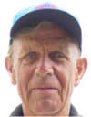
Robert Vernon Jackson only started playing in 1971 when he was in his mid-30s, and is still competing in both Association and Golf Croquet. Between 1979 and 1986 he was one of the world’s best players and known as an especially good match player. He has been playing the alternate form of the game, Golf Croquet for 12 years. He is a member of the Howick Croquet Club.
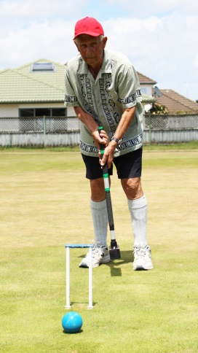
Bob Jackson has the most New Zealand titles as a 14-time national singles champion in Association croquet, the first in 1975 and last in 2003, with two three-peels in 1982-84 and 1997-99. He has won the NZ doubles title 10 times.
Since adding golf croquet to his playing schedule, which involves about five sessions a week, Jackson has become the national singles and doubles champion three times each.
On the international stage, he was a doubles world champion with Joseph Hogan at the 1989 tournament held in England, and came third in the singles at Rhode Island, United States, in 1992.
Widely renowned as one of the best players in the world in the late 1970s and 1980s, he was the first to perform an extremely rare move called an octuple peel in competitive play, and did it twice in consecutive matches.
He was inducted into the World Croquet Federation Hall of Fame in 2008, with the inscription:
“[ R.Jackson] developed a style of play which revolved around his strength at single ball shots which he hit with considerable power and accuracy. “
“His example encouraged others to take a more aggressive approach by shooting rather than finessing to gain the innings. “
Bob was a true exponent of the 80/20 rule – it is not what you will achieve if you hit, what you might give away if you miss. He often stood for some time looking at the balls before continuing play. This was his time of calculating the odds.
As if his feats in croquet weren’t enough, he is also a former New Zealand table tennis champion.
Bob competed in the two World Croquet Federation Golf Croquet Championships held in New Zealand in 2006 and 2015. He made the quarter-finals in Hawke’s Bay in 2006.
He was one of 18 Kiwis nominated to compete in 2015 by Croquet New Zealand, based on his national ranking of 11.
"Bob Jackson has manufactured good inexpensive mallets for over two decades, and has also supported the game by being one of the most prolific tournament entrants in the Southern hemisphere.
"He is well known for his calm unflappable demeanour, laconic style and dry sense of humour.
“Playing in the Men’s Championship on lawn 9 in Wanganui, Bob, in his frustration at hitting back and forth on the East boundary without connecting (his opponent Paul Skinley was having the same frustration on the West boundary) hit his striker’s ball so hard it bounced off the lawn and over the fence onto the St John’s Ladies Bowling Club lawns.
A lovely woman came and presented Bob with his black ball saying “I believe this is yours. It is of no use to us as it doesn’t have a bias on it. To which Bob - rapidly blinking his golden eyelashes over his blue eyes - replied – “Don’t you believe it Madam”

